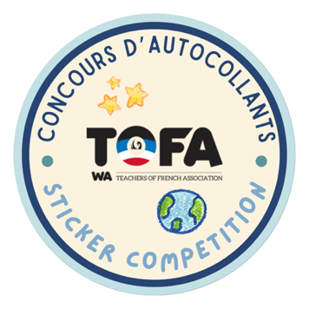
Sticker Competition 2026
The Teachers of French Association invites French students from Year PP-10 to participate in the annual TOFA Sticker Competition.

The theme of this year’s competition is “Cap sur la Nouvelle Hollande!”. See the document Guide pédagogique for ideas on how to approach this theme in French class.

Rules
▪ The competition is open to students of current TOFA members (2026).

▪ Each student must create one design inside the circle on the template sheet. Designs must be simple, clear and neatly presented.

▪ If using longer text (more than 5 words), it may be typed and carefully glued inside the circle.

▪ Students should use bright colours, outline shapes and letters, and remove all pencil marks.

▪ Designs will be disqualified if they include: English text, spelling mistakes, incomplete colouring, incorrect flags, inappropriate images – or do not follow the theme.

▪ The artwork must be original. Copying or tracing from the internet or books may breach copyright. (We can tell!)

▪ Each submission must be signed by both the teacher and the student to give permission for publication. (Only first names and initials will be used online.)

▪ A maximum of 5 designs per category per teacher may be submitted.

Due date & submission:

- Please scan and send all of your entries electronically in PDF or JPEG format by Friday 25th September 2026, to tofawa.au@gmail.com

- Designs of different categories can be sent in one email but must be in separate files. Save your scans as Categorynumber_Teachername_Schoolname.

Results & prizes

A jury will select the 3 designs that represent a variety across different schools and regions from 5 categories.

Category 1 | Year PP-2 | Category 3 | Year 5-6 | Category 5 | Year 9-10
Category 2 | Year 3-4 | Category 4 | Year 7-8

The winners will be announced in Week 1, Term 4 and will receive an electronic gift card shortly afterwards.
1st prize: $20 | 2nd prize: $10 | 3rd prize: $10

TOFA is looking forward to another year of amazing artwork from WA students!

